Chapter Three: Analysis Deliverables of the New System

3.1 Introduction
The analysis phase of the system development life cycle (SDLC) focuses on understanding and specifying the requirements of the proposed online LMS for Tsinseta High School. During this phase, UML models are used to capture functional requirements (e.g. use cases) and define the domain structure (e.g. class diagrams). For example, use-case modeling helps define what the system must do (e.g. assignment submission, quiz taking) by illustrating interactions between users (actors) and the LMS. Concurrently, an analysis-level domain model is constructed to represent key entities (classes) and their relationships. This chapter presents the analysis artifacts of the new LMS: the use-case diagram (with actor descriptions and textual use-case details), the analysis-level class diagram, a representative sequence diagram, an activity diagram for a workflow, and the user interface prototype sketches. Together, these deliverables define the functional scope and data structure of the LMS before design and implementation.

3.2 Use Case Diagram
The use case diagram (Figure 3.1) illustrates the interactions between the proposed Learning Management System (LMS) and its external actors. A use case represents a specific functionality or service that the system provides in response to an actor’s request. The diagram clearly defines the system boundary and shows how different users interact with the LMS to achieve their goals.
The LMS supports five primary actors: Student, Teacher, Homeroom Teacher, Administrator, and Parent. Each actor represents a distinct role within the academic and administrative structure of Tsinseta High School, as identified in the analysis of the existing system.
The Student actor interacts with the system to perform learning-related activities such as logging in, viewing course materials, submitting assignments, taking quizzes, viewing grades, checking attendance records, viewing announcements, and managing their account credentials. These use cases address the lack of continuous access to learning resources and delayed feedback present in the existing manual system.
The Teacher actor represents subject teachers responsible for course delivery and assessment. Teachers use the system to upload and manage course materials, create assignments and quizzes, record daily attendance, grade assignments and quizzes, post announcements, and view student performance. These interactions replace manual grading, paper-based attendance registers, and fragmented record keeping.
The Homeroom Teacher actor is a specialized role assigned to a teacher who oversees a specific class. In addition to normal teaching functions, the homeroom teacher interacts with the system to monitor class-level attendance, generate class performance reports, and communicate with students and parents. This role reflects the real organizational structure of the school and supports centralized monitoring of student progress.
The Administrator actor represents school management staff such as the principal or office personnel. Administrators interact with the system to create and manage user accounts, assign roles, enroll students into classes, assign teachers to courses, activate or deactivate accounts, configure system settings, and generate academic and attendance reports. These use cases support efficient school administration and decision-making.
The Parent actor provides external access to the system for guardians of students. Parents can log in to view their child’s academic progress, attendance records, and announcements, and communicate with teachers or homeroom teachers. This functionality improves transparency and strengthens parent–school communication, which was limited in the existing system.
Overall, the use case diagram ensures that all functional requirements of the proposed LMS—such as digital content access, assessment management, attendance tracking, reporting, communication, and administration—are clearly identified and linked to the appropriate actors. This model serves as a foundation for detailed use case specifications and subsequent system design activities.
. 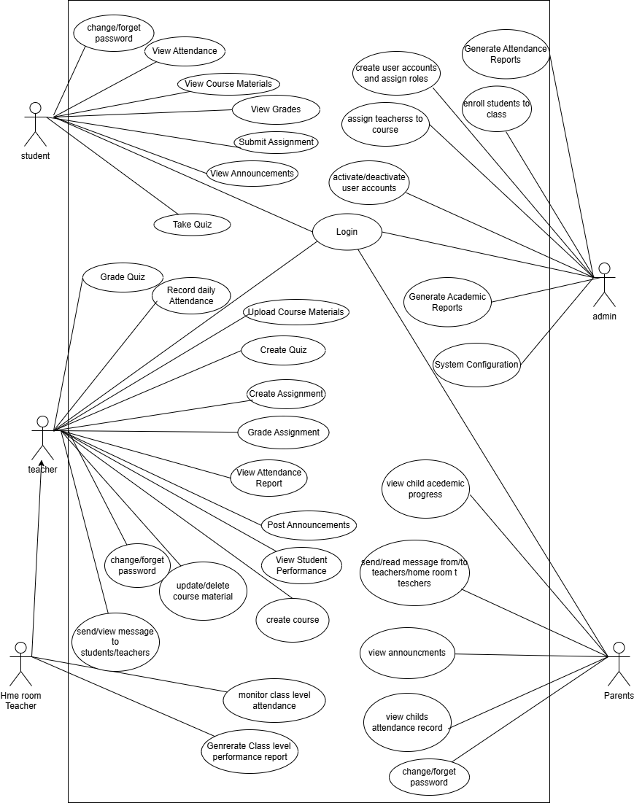
Online Learning Management System
Figure 3.1: Use Case Diagram of the Proposed LMS

3.2.1 Actor Description
The proposed Learning Management System (LMS) involves multiple actors who interact with the system according to their roles and responsibilities within Tsinseta High School. These actors are derived directly from the analysis of the existing system and the functional requirements of the proposed system. Table 3.1 summarizes the main actors and their descriptions.
Student
A student is a learner enrolled in one or more courses at Tsinseta High School. Students use the LMS to access digital learning materials such as lecture notes and announcements, submit assignments, take quizzes, and view their grades and attendance records. Students must authenticate themselves to access personalized academic information. The system replaces the traditional paper-based access to learning materials and assessments.
Teacher
A teacher is responsible for delivering instruction for one or more courses. Teachers use the LMS to upload and manage course materials, create assignments and quizzes, record daily attendance, grade assignments and quizzes, and post announcements for students. The LMS supports teachers by automating assessment handling and maintaining a centralized digital gradebook.
Homeroom Teacher (Class Teacher)
The homeroom teacher is a specialized role assigned to a teacher who oversees a specific class. In addition to normal teaching responsibilities, the homeroom teacher monitors overall class-level attendance and academic performance, generates class performance reports, communicates with parents, and follows up on student progress and absenteeism. This role reflects the real organizational structure of Tsinseta High School and is explicitly supported by the LMS.
Administrator
The administrator represents school management staff such as the principal or office personnel. Administrators manage system-wide operations including creating user accounts, assigning roles, enrolling students into classes, assigning teachers to courses, activating or deactivating accounts, configuring system settings, and generating academic and attendance reports. The LMS automates administrative tasks that were previously handled manually.
Parent
A parent is an external stakeholder who monitors a student’s academic progress. Through the LMS, parents can securely log in to view their child’s academic performance, attendance records, and school announcements, as well as communicate with teachers or homeroom teachers. This role addresses the lack of timely parent–school communication identified in the existing system.

3.2.2 Use Case Textual Descriptions
This section provides formal textual descriptions of the principal use cases identified in the use case diagram. Each use case is documented using a standardized structure consisting of the actor(s), preconditions, main flow of events, and postconditions. These descriptions clarify the functional behavior of the proposed Learning Management System (LMS) and ensure traceability between system requirements and user interactions, as identified in Chapters One and Two.
Use Case 1: User Authentication (Login)
Actors: Student, Teacher, Homeroom Teacher, Administrator, Parent
Preconditions:
- The user has a valid system account created and authorized by the system administrator.
Main Flow:
- The user accesses the LMS login interface.
- The user enters valid authentication credentials (username and password).
- The system verifies the credentials against stored user records.
- Upon successful authentication, the system establishes a secure session and redirects the user to the appropriate role-based dashboard.
Postconditions:
- The user is successfully authenticated and granted access privileges corresponding to their assigned role.
Use Case 2: Access Course Materials
Actor: Student
Preconditions:
- The student is authenticated.
- The student is enrolled in the selected course.
Main Flow:
- The student selects a course from the dashboard interface.
- The system retrieves and displays the associated instructional materials, including lecture notes and supplementary resources.
- The student views or downloads the required materials.
Postconditions:
- Course materials are accessed and made available to the student for learning purposes.
Use Case 3: Submit Assignment
Actor: Student
Preconditions:
- The student is authenticated.
- The assignment is active and within the submission deadline.
Main Flow:
- The student navigates to the assignment submission page.
- The student uploads the assignment file or enters the required response.
- The system validates the submission and stores it in the database.
- A confirmation message is displayed to the student.
Postconditions:
- The assignment submission is successfully recorded and made available for instructor evaluation.
Use Case 4: Take Quiz
Actor: Student
Preconditions:
- The student is authenticated and enrolled in the course.
- The quiz is available within the defined access period.
Main Flow:
- The student initiates the quiz from the course interface.
- The system presents the quiz questions according to predefined settings.
- The student submits responses for all questions.
- The system evaluates the quiz automatically where applicable or flags it for manual grading.
Postconditions:
- The student’s quiz attempt and score are recorded in the system.
Use Case 5: Upload Course Materials
Actor: Teacher
Preconditions:
- The teacher is authenticated and assigned to the relevant course.
Main Flow:
- The teacher selects the course management module.
- The teacher uploads instructional materials.
- The system stores the materials and publishes them to enrolled students.
Postconditions:
- Course materials are available to students through the LMS.
Use Case 6: Create Assignment
Actor: Teacher
Preconditions:
- The teacher is authenticated and authorized for the course.
Main Flow:
- The teacher defines assignment details, including instructions and deadlines.
- The system saves and publishes the assignment.
Postconditions:
- The assignment is accessible to enrolled students for submission.
Use Case 7: Evaluate Assignment
Actor: Teacher
Preconditions:
- Student submissions exist for the assignment.
Main Flow:
- The teacher reviews submitted assignments.
- The teacher assigns grades and provides feedback.
- The system records the evaluation results.
Postconditions:
- Assignment grades and feedback are stored and made visible to students.
Use Case 8: Create Quiz
Actor: Teacher
Preconditions:
- The teacher is authenticated and assigned to the course.
Main Flow:
- The teacher defines quiz parameters and questions.
- The system publishes the quiz for student access.
Postconditions:
- The quiz is available to students during the specified period.
Use Case 9: Record Daily Attendance
Actor: Teacher
Preconditions:
- The teacher is authenticated and assigned to the class.
Main Flow:
- The teacher accesses the attendance module.
- Attendance status is recorded for each student.
- The system stores the attendance data.
Postconditions:
- Attendance records are updated and available for reporting.
Use Case 10: Monitor Class Performance
Actor: Homeroom Teacher
Preconditions:
- The homeroom teacher is authenticated and assigned to a class.
Main Flow:
- The homeroom teacher accesses class-level reports.
- The system displays aggregated academic and attendance data.
- The homeroom teacher reviews student progress.
Postconditions:
- Class performance and attendance trends are monitored.
Use Case 11: Generate Academic and Attendance Reports
Actors: Administrator, Homeroom Teacher
Preconditions:
- The user has reporting privileges.
Main Flow:
- The user selects the required report type.
- The system processes stored academic and attendance data.
- The generated report is displayed or exported.
Postconditions:
- Accurate reports are produced to support administrative decision-making.
Use Case 12: Manage User Accounts
Actor: Administrator
Preconditions:
- The administrator is authenticated.
Main Flow:
- The administrator creates, updates, or deactivates user accounts.
- Roles and permissions are assigned or modified.
- The system updates the user repository.
Postconditions:
- User accounts and access rights are correctly maintained.
Use Case 13: View Student Academic Progress
Actor: Parent
Preconditions:
- The parent is authenticated and linked to a student account.
Main Flow:
- The parent selects the student profile.
- The system displays academic results and attendance information.
Postconditions:
- Parents are informed of the student’s academic status.
Use Case 14: Publish and View Announcements
Actors: Teacher, Administrator (Publish); Student, Parent (View)
Preconditions:
- The user is authenticated.
Main Flow:
- Authorized users publish announcements.
- The system disseminates announcements to intended users.
- Other users access announcements via their dashboards.
Postconditions:
- Announcements are successfully communicated to relevant stakeholders.
3.3 Analysis-Level Class Diagram
The The analysis-level class diagram (Figure 3.2) defines the principal domain classes of the proposed Learning Management System (LMS) and the relationships among them. In Unified Modeling Language (UML), a class diagram represents the static structure of a system, showing its key classes (entities), their attributes, and the associations between them. At the analysis stage, the class diagram serves as a conceptual data model, focusing on what information the system must manage, without including implementation or technical details such as methods or data types.
For the proposed LMS, the main domain classes include User, Course, Assignment, Submission, Quiz, Question, Grade, and Attendance. The User class represents all system users and is specialized through inheritance into Student, Teacher, Homeroom Teacher, Administrator, and Parent, reflecting the different roles identified in the use case analysis. Typical attributes include User.userID, User.name, username, password, and role, while academic entities include attributes such as Course.courseID, Course.title, Assignment.assignmentID, Assignment.dueDate, and Submission.timestamp.
Associations in the diagram capture the logical relationships between these classes. For example, students are enrolled in courses, a course contains multiple assignments and quizzes, and an assignment has many submissions. Each submission is associated with exactly one student and one assignment, ensuring accurate tracking of assessment data. A quiz is composed of multiple questions, and grades are associated with students and their corresponding assessments. Attendance records link students to class sessions managed by teachers.
Using an analysis-level UML class diagram helps verify that all essential entities and relationships required to support learning activities, assessment management, attendance tracking, and reporting are identified before system design and implementation. This model ensures that the LMS has a well-defined structural foundation that aligns with the functional requirements described in the use case model.
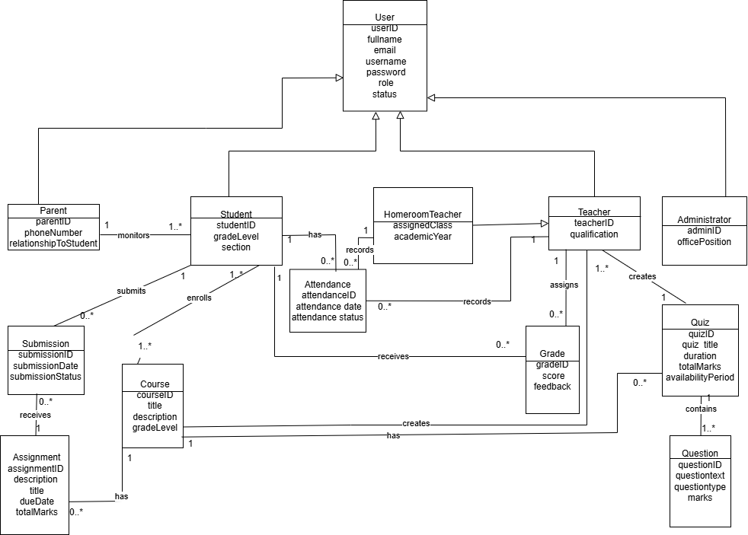
Figure 3.2: Analysis-Level Class Diagram for the Proposed LMS.
The diagram presents key classes with their core attributes and shows inheritance from the User class to its role-specific subclasses. Associations illustrate relationships such as a Course having multiple Assignments, Students submitting Assignments, and Quizzes consisting of Questions. This conceptual model clarifies the data structures and relationships needed to support the LMS prior to the design phase.
3.4 Sequence Diagram
A sequence diagram illustrates object interactions over time for a specific scenario. In UML, sequence diagrams are dynamic, time-focused diagrams that detail how operations are carried out and how objects collaborate. Figure 3.3 shows a sample sequence for the “Submit Assignment” use case. Here, lifelines represent instances of objects (e.g. StudentUI, Course, Assignment, SubmissionSystem). Arrows between lifelines indicate messages (method calls or data exchanges) in chronological order. For example, when a student submits an assignment, the Student actor’s UI sends a submitAssignment() message to the Course object, which in turn invokes the Assignment object. The Assignment object creates a new Submission entry and calls the Gradebook or Storage system to persist it. The sequence diagram emphasizes the order of these interactions and the participating objects. By modeling this flow, developers can verify the logic of the scenario (e.g. ensuring a Submission is recorded) before coding.
Figure 3.3: Sequence Diagram for “Submit Assignment” Scenario (placeholder). This interaction diagram shows the student actor and key system objects over time. Vertical dashed lines are lifelines; horizontal arrows are messages (e.g. StudentUI→Course: submitAssignment()). It captures the chronological steps: the student sends the assignment data, the system locates the appropriate Assignment instance, creates a Submission record, and returns an acknowledgement. Sequence diagrams like this one help document the dynamic behavior of the system during a use case.

3.5 Activity Diagram
An activity diagram models the workflow of actions for a business process or use case. It is essentially a flowchart of the system’s operations. Figure 3.4 depicts an activity diagram for the “Take Quiz” workflow. The diagram begins with a start node, followed by activities such as Display Question, Record Answer, and decision points (e.g. More Questions?). For instance, the student initiates the quiz, and the system presents each question in turn. After the student answers, control flows back to either display the next question or to end the quiz when all questions are answered or time expires. Finally, the system computes and shows the quiz score (final activity) before reaching the end node. This flowchart-like representation clarifies all steps and decision branches in the quiz-taking process (including loops and parallel activities if any). By detailing this workflow in an activity diagram, we ensure that every action (like checking time limits or saving each answer) is planned before design.
Figure 3.4: Activity Diagram for “Take Quiz” Workflow (placeholder). The flow starts at Start, then the system presents Question 1. The student submits Answer 1, and a decision node checks if there are more questions. This loop continues until the quiz ends; then the system calculates Score and displays results. Decision diamonds represent branches (e.g. “Time’s up?” or “All questions answered?”). Activity diagrams are especially useful to capture concurrent or conditional flows. In this UML model, the vertical flow of actions depicts the operational steps a student and the system follow during a quiz.

3.6 User Interface Prototype
The user interface (UI) prototypes sketch the key screens of the LMS. Each screen is described below, along with a figure for illustration. These designs are low-fidelity mock-ups to convey layout and functionality.
- Login Screen: The login page is the entry point to the LMS. It has fields for Username and Password, and a Log In button. Optionally, it may include links for password recovery or language selection. The layout is simple and uncluttered to allow quick access. (Figure 3.5 is a placeholder sketch.)
Figure 3.5: Sketch of LMS Login Screen (placeholder). The user enters credentials here. After login, the system directs the user to their personalized dashboard.
- Student Dashboard: After logging in, students see a dashboard summarizing their courses and tasks. The dashboard lists enrolled courses as tiles or a menu. Each course entry shows basic info (course title, instructor name) and may display pending items (e.g. “1 assignment due”). Navigation links allow the student to go to the course page or view grades. Additional sections could include announcements or a calendar. The dashboard is the main landing page for students, showing an overview of their learning activities. (Placeholder for student dashboard sketch.)
- Course Content Page: Within a selected course, the content page displays the course materials. This screen is divided into sections or tabs (e.g. Lectures, Assignments, Quizzes). Under Lectures, there are links to notes, slides or videos. The Assignments section lists assignments with their due dates and submission buttons. The Quizzes section lists available quizzes. Teachers see additional options (e.g. Create Assignment button). The page is organized so that students can easily browse resources and upcoming assessments. (Placeholder for course content page sketch.)
- Assignment Submission Page: When a student selects an assignment, the system shows the assignment details (title, description, due date, attached files). There is an upload control or text-entry box for the student’s solution. A Submit button allows uploading the work. After submission, the student sees a confirmation message. For teachers, this screen lists all student submissions, with options to download or view each submission. The design emphasizes clarity of deadlines and submission status. (Placeholder for assignment submission screen sketch.)
- Quiz Interface: The quiz-taking screen presents questions to the student. Depending on design, questions may appear one at a time or all at once. For each question (multiple choice, true/false, or essay), the interface provides input controls (radio buttons, text fields). A timer may be shown if the quiz is timed. Navigation buttons allow moving between questions (e.g. Next, Previous). At the end, the student clicks Submit Quiz, after which the system displays the score and correct answers. The layout is clean to minimize confusion during the exam. (Placeholder for quiz screen sketch.)
- Teacher Dashboard/Gradebook: The teacher’s main interface shows their courses and pending tasks. The dashboard lists each course the teacher instructs. For each course, quick links lead to grading interfaces. The gradebook screen for a course displays a table of students and their assignment/quiz scores, allowing the teacher to enter or adjust grades. Teachers can click on an assignment to grade individual submissions. The UI prioritizes efficiency for instructors to manage and record student performance. (Placeholder for teacher gradebook interface sketch.)
Each of these UI screens corresponds to a key user interaction identified in the use cases. The sketches ensure that essential elements (like login fields, navigation menus, content lists, and buttons) are planned before the visual design phase.

